DBMS WEEK 1

SECTION-1: DDL COMMANDS: (DATA DEFINITION LANGUAGE)

- CREATE
- ALTER
- DROP
- TRUNCATE
- RENAME

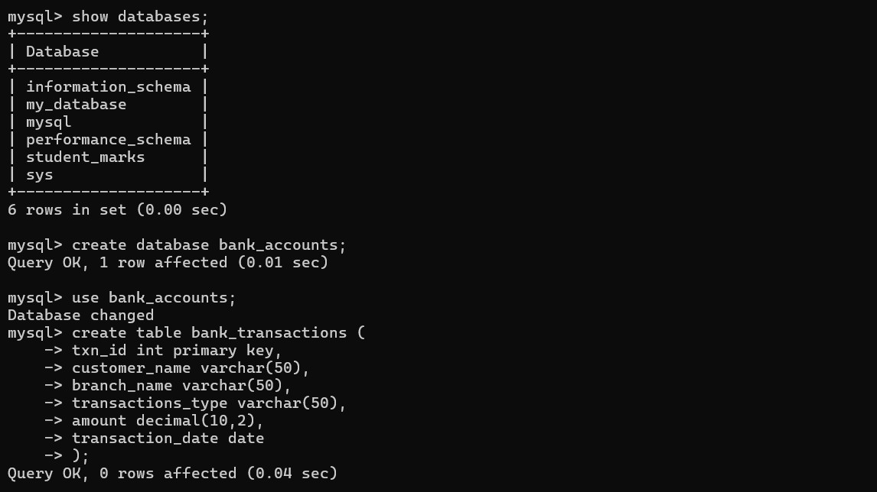
QUESTION 1 - CREATE TABLE:

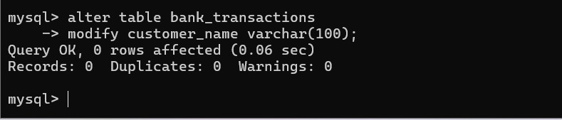

QUESTION 3 - ALTER TABLE MODIFY COLUMN
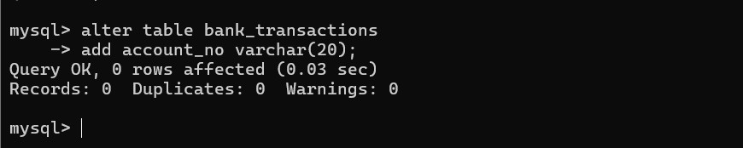

QUESTION 4 - RENAME TABLE

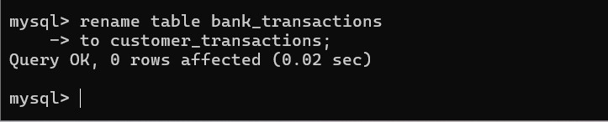

QUESTION 5 - TRUNCATE TABLE

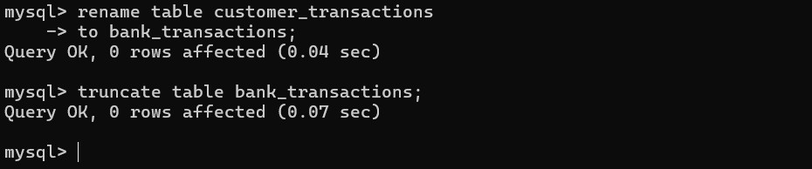

QUESTION 6 - DROP TABLE

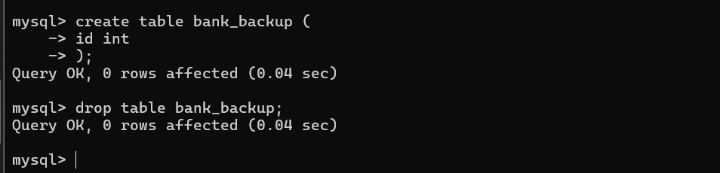

SECTION 2 : DML (DATA MANIPULATION LANGUAGE)

DML COMMANDS:
- insert
- update
- delete
- select

STEP 1 : INSERT SAMPLE DATA
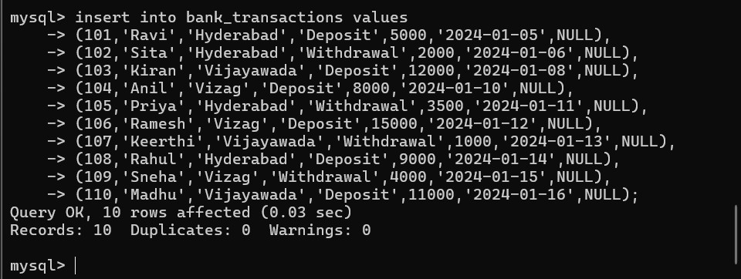

QUESTION 7 – INSERT
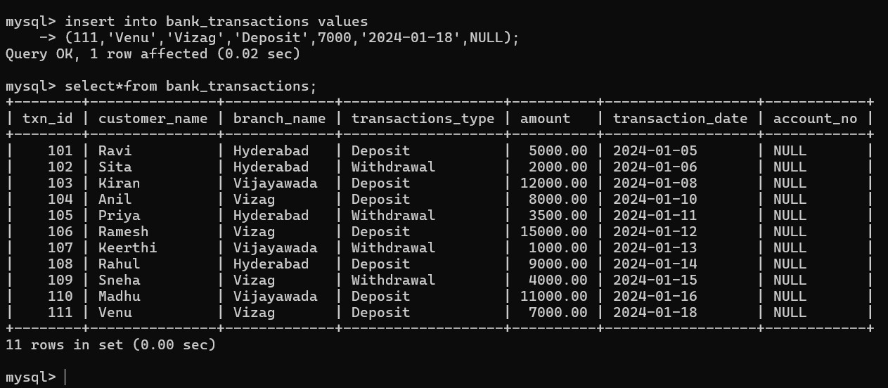

QUESTION 8 – UPDATE
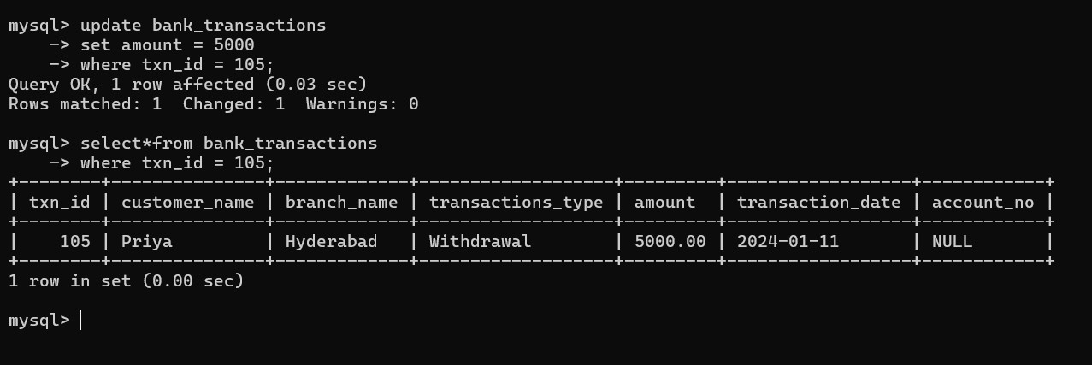

QUESTION 9 – DELETE

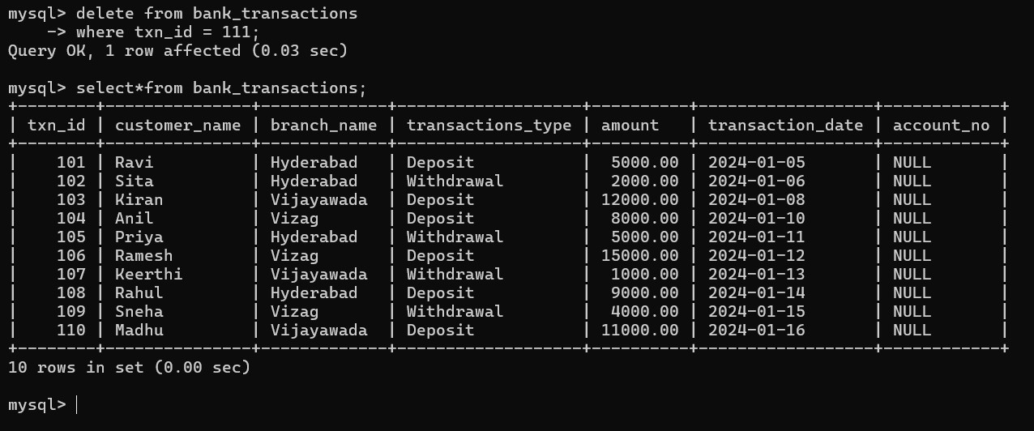

QUESTION 10 - SELECT

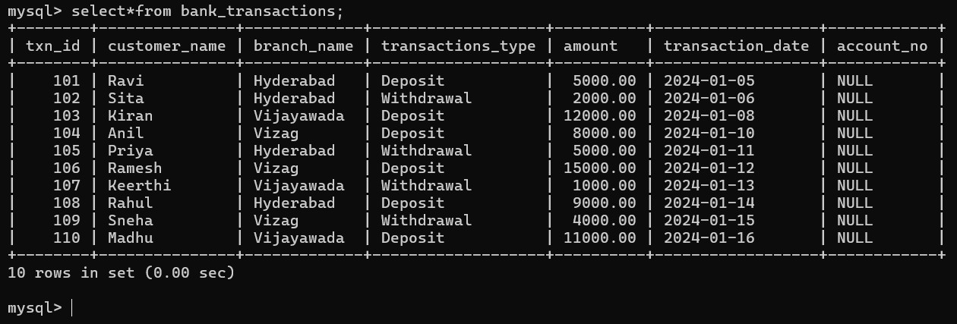

QUESTION 11 SELECT WITH WHERE
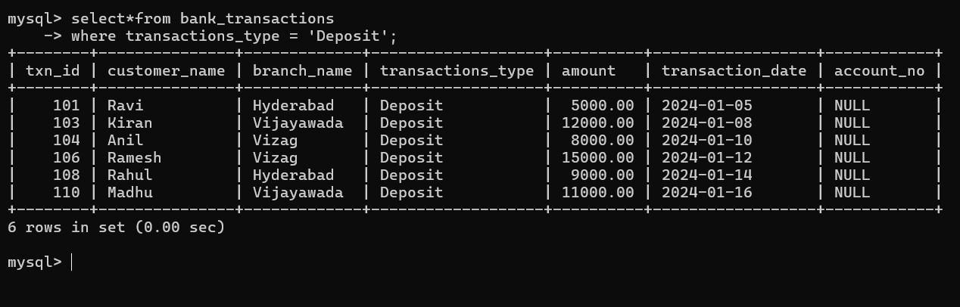

QUESTION 12 - SELECT WITH ORDER BY
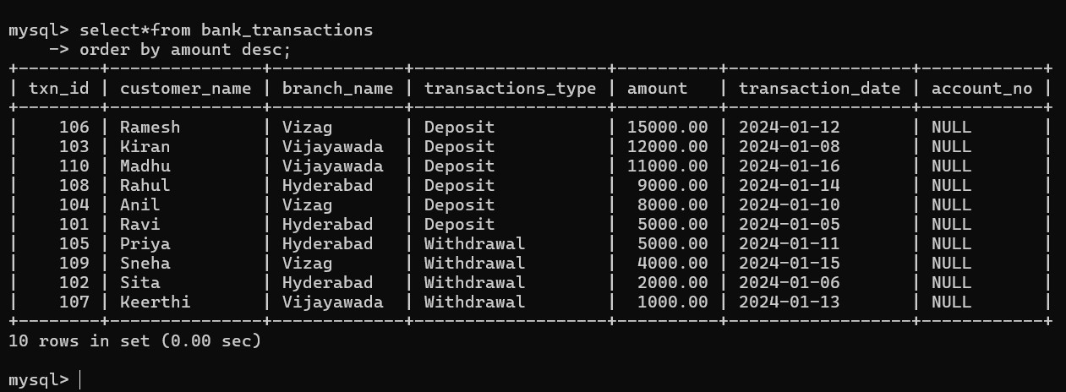

SECTION 3 : DCL (DATA CONTROL LANGUAGE)

DCL COMMANDS:
- grant
- revoke

QUESTION 13 - GRANT SELECT
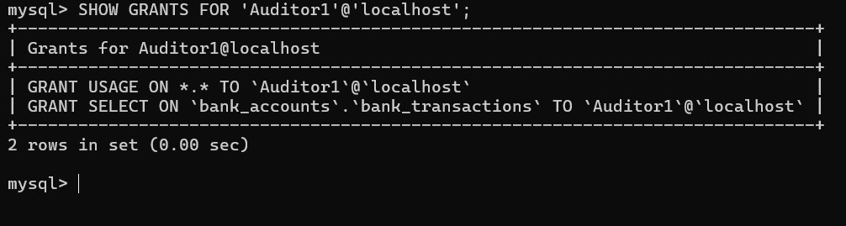

QUESTION 14 - GRANT ALL PRIVILEGES

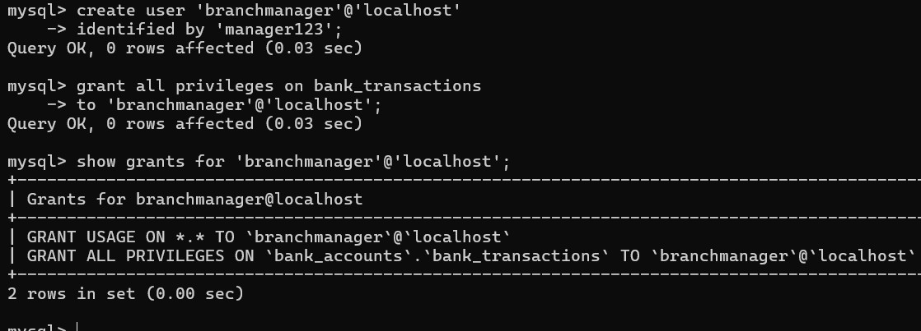

QUESTION 15 - REVOKE SELECT

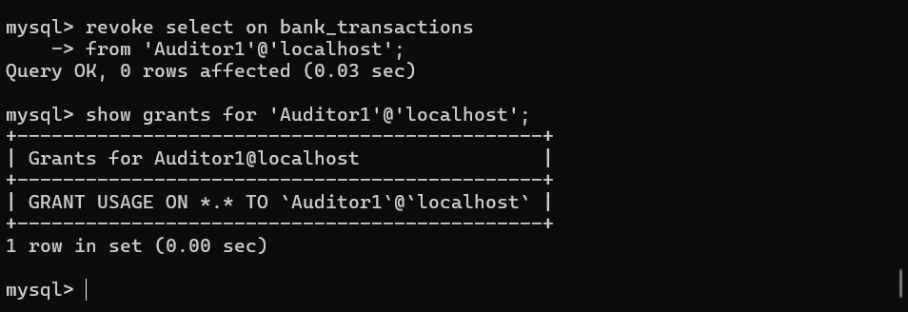

QUESTION 16 REVOKE ALL
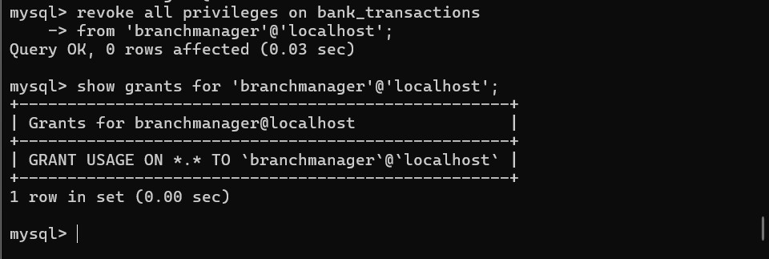

SECTION 4 : TCL (TRANSACTION CONTROL LANGUAGE)

TCL COMMANDS:
- commit
- savepoint
- rollback

QUESTION 17 – COMMIT
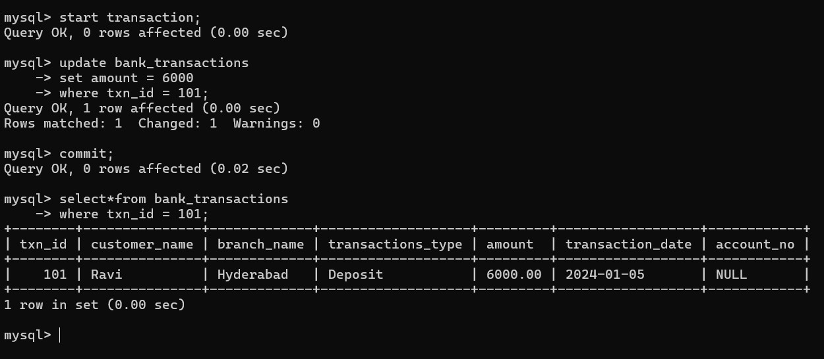

QUESTION 18 – SAVEPOINT
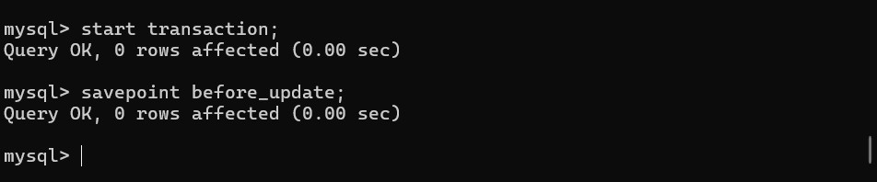

QUESTION 19 - ROLLBACK TO SAVEPOINT
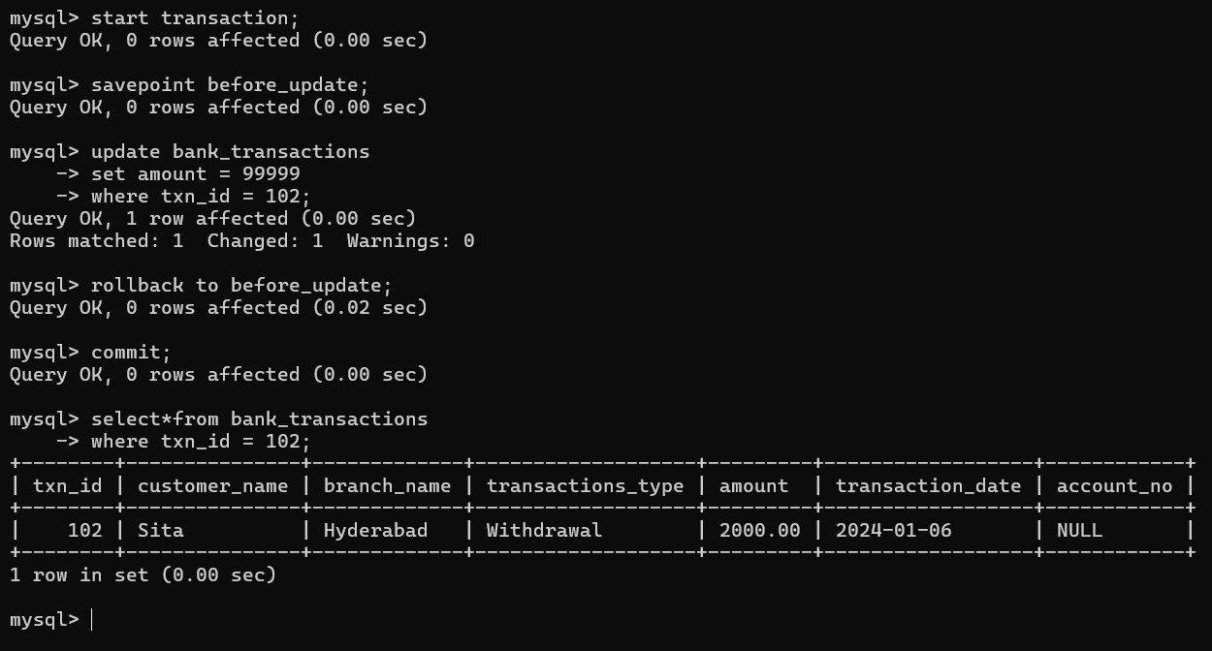

QUESTION 20 FULL TCL EXAMPLE

